Machine Learning-Driven Virtual Screening for Novel HER2/ERBB2 Inhibitor Discovery Using ChEMBL IC50 Dataset with Ensemble Classification and Soft-Voting Prediction
Afiya Mubasharah
Dept. of Biomedical
Engineering
Islamic University
Kushtia, Bangladesh

Tanima Roy
Department of Data Intelligence
Canterbury Christ Church University
Canterbury, UK
amitbme08@gmail.com
Dewan Md. Tanzilul Hamim
Dept. of Biomedical
Engineering
Jashore University of Science
and Technology
Jashore-7408, Bangladesh hamim.just@gmail.com

Abu Talha
Dept. of Physics
Jashore University of Science
and Technology
Jashore, Bangladesh abutalha.just@gmail.com
Enamul Kabir Talukder
College of Pharmacy
University of Louisiana at Monroe
Monroe, USA
rohitrohandas2@gmail.com

Asif Abdullah
Dept. of Biomedical
Engineering
Jashore University of Science
and Technology
Jashore-7408, Bangladesh a.abdullah@just.edu.bd

Abstract—Overexpression of the HER2/ERBB2 receptor tyrosine kinase is directly linked with aggressive tumor progression and oncogenic signaling, making it a critical therapeutic target. The study develops and validates a robust machine learning pipeline that identifies potential HER2 inhibitor candidates using a ChEMBL-based dataset. Compound dataset was curated through multilayer filtration process, RDKit-based SMILES standardization, salt removal, resulting in 1,939 descriptor-ready compounds. Bioactivity data (IC50, nM) were extracted from CHEMBL1824, classifying the compunds in two segments (861 active, IC50 ≤ 100 nM; 1,078 inactive). In total, 1,436 1D/2D molecular features were computed via PaDEL, which was filtered into 506 by removing low variance and high Pearson correlation (r > 0.90). Thirty binary classifiers were trained on an 80/20 stratified split and evaluated by 5-fold cross-validation to create a performance benchmark. Four of the best performing models: XGBoost, LightGBM, ExtraTrees, and BaggingTrees were integrated into a soft-voting ensemble to predict compunds, achieving ROC-AUC = 0.911, accuracy = 81.7%, sensitivity = 76.7%, specificity = 85.6%, F1-score = 0.788, and MCC = 0.628 on test set. To confirm the models genuine understanding between structure–activity relationship (SAR), dataset was subjected to Y-scrambling validation (50 iterations), yielding a significant mean scrambled AUC of 0.506 ± 0.043.
Keywords—HER2, ERBB2, machine learning, ChEMBL, molecular descriptors, QSAR, ensemble learning, virtual screening

Introduction
Human epidermal growth factor receptor 2 (HER2/ERBB2) is a receptor tyrosine kinase whose gene amplification or protein overexpression is a characteristic in approximately 15–20% of breast cancers and is also found in subsets of gastric, lung, and colorectal malignancies [1]. HER2 amplification contributes to poor prognosis and resistance to conventional therapy by activating downstream proliferation and survival pathways [2]. Although clinically approved agents such as trastuzumab, pertuzumab, and lapatinib have substantially improved clinical outcomes, acquired resistance with time and cardiotoxicity limit long-term efficacy, driving the need for novel HER2 inhibitors. [3].
In silico approaches accelerate early-stage inhibitor identification by filtering large chemical libraries, prior to resource-intensive laboratory synthesis and biological assays [4]. Quantitative structure–activity relationship (QSAR) modelling links molecular descriptors to biological activity and can predict active compounds from chemical structure alone [5]. To construct a reliable foundation for QSAR dataset, standardized IC50 measurements for kinase-targeted compounds were collected from ChEMBL, a publicly curated bioactivity database [6]. Ensemble machine learning methods integrate predictions of multiple base learners to reduce variance and improve generalization [7]. PaDEL-Descriptor generates 1D and 2D molecular descriptors without 3D conformational search, facilitating large-scale ligand-based screening [9]. Y-scrambling (label permutation) is incorporated as a negative control tecnique to confirm genuine structure–activity relationship learning [10].
The objectives of this study were: (i) to construct an IC50 binary based high-quality HER2 classification dataset from ChEMBL; (ii) to create a benchmark from training 30 diverse machine learning classifiers using PaDEL descriptors; (iii) to assemble a soft-voting ensemble from the top-performing models; (iv) to validate model integrity via Y-scrambling; and (v) to computationally prioritize HER2 inhibitor candidates for further investigation.

Related Work
Since Several studies have applied QSAR and machine learning to predict HER2 inhibitory activity. Kanwal et al. developed QSAR models for EGFR/HER2 dual inhibitors using 2D fingerprints and support vector machines, reporting satisfactory cross-validated ROC-AUC values [12]. Lo et al. demonstrated that ensemble tree models outperform logistic regression in kinase bioactivity classification across multiple ChEMBL datasets [13]. Wu et al. showed that 2D topological descriptors combined with gradient boosting methods provided robust kinase inhibitor QSAR performance [16]. Svetnik et al. established the utility of random forests for QSAR [14], while Sheridan et al. showed that combining multiple models reduces prediction variance [15]. Despite these advances, no previous study has systematically benchmarked 30 machine learning classifiers on a freshly curated HER2 ChEMBL IC50 dataset, followed by Y-scrambling validation as a QSAR reliability test and soft-voting ensemble-based virtual screening. In addition, this workflow identifies several key novel compounds that may serve as promising candidates for further computational validation and experimental confirmation.

Methodology

Data Collection and Curation
IC50 values for HER2/ERBB2 inhibitors (ChEMBL target ID: CHEMBL1824) were downloaded from ChEMBL.[6]. Filters retained only records with standard_type = IC50, standard_units = nM, and standard_relation = "=". Records missing canonical SMILES, non-numeric IC50 values, or negative concentrations were removed. Biochemical direct-binding assays were preferred when multiple assay entries existed per compound. SMILES standardization was performed using RDKit [11] and the workflow includes salt stripping through largest-fragment selection, molecule normalization, neutralization, and sanitization. Active (IC50 ≤ 100 nM) and inactive (IC50 > 100 nM) binary labels were assigned based on IC50 values of compounds.

Descriptor Calculation and Preprocessing

Initially, 1,436 1D/2D molecular descriptors were extracted by PaDEL-Descriptor v2.21 [9] and descriptors with pairwise Pearson correlation |r| > 0.90 were removed. The 506 retained descriptors were scaled to [0,1] using MinMaxScaler, and to prevent data leakage, the scaler was fitted only on the training set.

Dataset Splitting and Model Training
The 1,939-compound was divided into training set (n = 1,551) and independent test set (n = 388) in an 80:20 proportion via stratified random splitting (seed = 42). Thirty binary classifiers including linear models (logistic regression, ridge, linear SVC, SGD-based models), probabilistic models (naïve Bayes, LDA, QDA), instance-based learning (k-NN), tree-based models (decision trees, extra trees, random forests, bagging), boosting methods (gradient boosting, histogram gradient boosting, AdaBoost, XGBoost [7], LightGBM [8]), and neural networks (MLPs) were trained Each classifier was evaluated by 5-fold stratified cross-validation (CV) and on the held-out test set. Benchmark metrics included ROC-AUC, accuracy, sensitivity, specificity, precision, F1-score, MCC, and R² (from predicted probabilities).

Ensemble Construction and Y-Scrambling
Models were evaluated by a weighted composite score:
S = 0.45×CV-AUC + 0.20×Test-AUC + 0.15×Test-MCC + 0.10×Test-F1 + 0.10×CV-MCC
Top four best performing models were merged into a soft-voting ensemble that averages class probabilities. For Y-scrambling verification [10], the training labels were randomly permuted over 50 independent iterations, and model performance was evaluated against these randomized baselines. The ensemble was retrained each time, yielding a null AUC/R² distribution in compare with original performance.

Results And Discussion

Dataset Curation
The curation pipeline (Table I) produced 1,939 descriptor-ready compounds from 3,329 initial ChEMBL bioactivity records. The final dataset contained 861 active compounds (44.4%) and 1,078 inactive compounds (55.6%), indicating a marginal imbalance in majority-minority ratio (1.25:1).
- DATASET CURATION SUMMARY
Curation Step | Compounds
Raw ChEMBL records | 3,329
After exact IC50 filter | 3,322
After numeric/positive IC50 | 3,004
After assay type preference | 2,909
After RDKit standardization | 3,004
After SMILES deduplication | 2,479
After descriptor filtering | 1,939
Active (IC50 ≤ 100 nM) | 861
Inactive (IC50 > 100 nM) | 1,078
Majority : minority ratio | 1.25:1

Descriptor Generation

A After variance and correlation filtering from 1,436 raw PaDEL descriptors, 506 features were retained (Table II).
- DESCR IPTOR AND CLASS DISTRIBUTION
Parameter | Value
Raw PaDEL descriptors | 1,436
Descriptors after preprocessing | 506
Modeling compounds | 1,939
Training set (80%) | 1,551
Test set (20%) | 388
Active compounds | 861 (44.4%)
Inactive compounds | 1,078 (55.6%)

Model Benchmarking
All 30 classifiers achieved test ROC-AUC > 0.72, and tree-based gradient boosting methods consistently outperformed linear and kernel-based classifiers. LightGBM scored the highest test AUC (0.914), followed by XGBoost (0.912) and HistGradientBoosting (0.911).Table III summarizes the top 10 performers. Fig. 1 shows the AUC bar chart for all 30 models; Fig. 2 shows the 5-fold CV AUC distribution

- TOP 10 MODEL PERFORMANCE ON INDEPENDENT TEST SET
Model | CV AUC ± SD | Test AUC | Acc | Sens | Spec | Prec | F1 | MCC
LightGBM | 0.892±0.022 | 0.908 | 0.825 | 0.773 | 0.866 | 0.821 | 0.796 | 0.644
HistGradBoost | 0.890±0.021 | 0.908 | 0.809 | 0.750 | 0.856 | 0.806 | 0.777 | 0.612
XGBoost | 0.892±0.020 | 0.907 | 0.00000830 | 0.802 | 0.852 | 0.812 | 0.807 | 0.655
RandomForest | 0.886±0.019 | 0.904 | 0.814 | 0.756 | 0.861 | 0.813 | 0.783 | 0.623
ExtraTrees | 0.890±0.021 | 0.903 | 0.822 | 0.750 | 0.880 | 0.832 | 0.789 | 0.639
BaggingTrees | 0.888±0.017 | 0.900 | 0.814 | 0.773 | 0.847 | 0.801 | 0.787 | 0.623
KNN_Distance | 0.873±0.027 | 0.896 | 0.820 | 0.779 | 0.852 | 0.807 | 0.793 | 0.633
GradBoosting | 0.879±0.021 | 0.891 | 0.796 | 0.744 | 0.838 | 0.785 | 0.764 | 0.586
KNN_11 | 0.858±0.024 | 0.888 | 0.791 | 0.779 | 0.801 | 0.757 | 0.768 | 0.578
QDA_Reg | 0.872±0.015 | 0.887 | 0.709 | 0.965 | 0.505 | 0.608 | 0.746 | 0.511

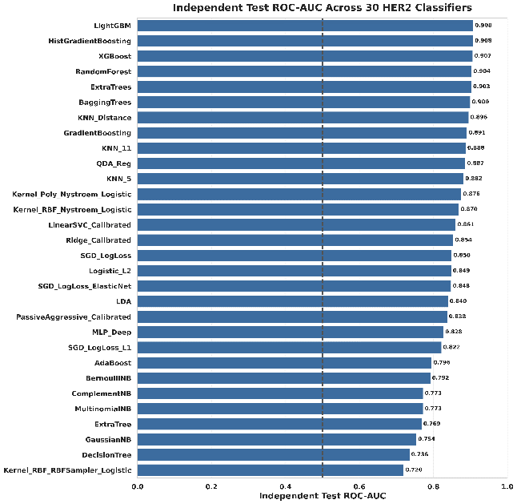
- Independent test ROC-AUC for all 30 HER2 classifiers. Tree-based boosting models consistently led. The dashed line marks the random baseline (AUC = 0.5).

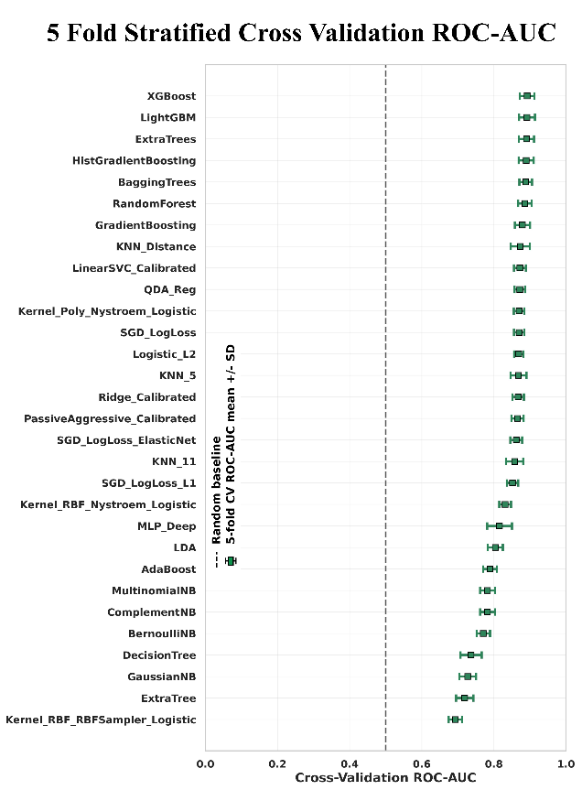
- Five-fold stratified cross-validation ROC-AUC for all 30 classifiers sorted by performance

Top Four Models and Ensemble
The XGBoost, LightGBM, ExtraTrees, and BaggingTrees were ranked as the four highest-performing models according to weighted composite score (Table IV). Soft-voting ensemble of top models obtained ROC-AUC = 0.911 on the independent test set (Table V), surpassing every individual model.
- TOP FOUR SELECTED MODELS AND SELECTION SCORES
Model | CV AUC | Test AUC | MCC | Score
XGBoost | 0.892 | 0.907 | 0.655 | 0.823
LightGBM | 0.892 | 0.908 | 0.644 | 0.820
ExtraTrees | 0.890 | 0.903 | 0.639 | 0.818
BaggingTrees | 0.888 | 0.900 | 0.623 | 0.813
- SOFT-VOTING ENSEMBLE INDEPENDENT TEST PERFORMANCE
Metric | Value
ROC-AUC | 0.911
Accuracy | 0.817
Sensitivity (Recall) | 0.767
Specificity | 0.856
Precision | 0.810
F1-Score | 0.788
MCC | 0.628
R² (predicted prob.) | 0.517
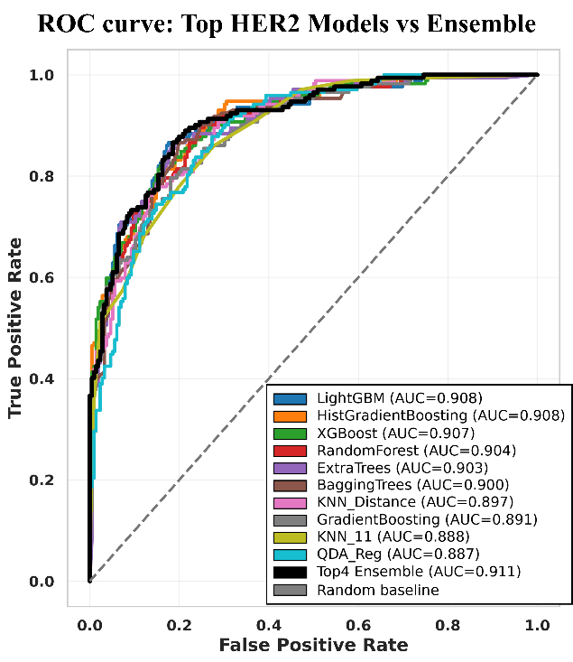
- ROC curves of top 10 models and the soft-voting ensemble. The ensemble (AUC = 0.911) lies at or above all individual model curves.
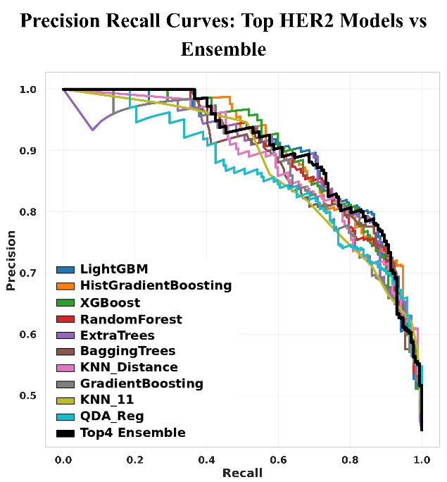
- ROC curves of top 10 models and the soft-voting ensemble. The ensemble (AUC = 0.911) lies at or above all individual model curves

Confusion Matrix Analysis
The ensemble was able to correctly classify 185 of 216 inactive compounds (specificity 85.6%) and 132 of 172 active compounds (sensitivity 76.7%). Fig. 5 presents the four combined confusion matrices. While XGBoost achieved highest true positive count (138), the ensemble demonstrated better sensitivity and specificity throughout.
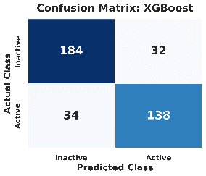 | 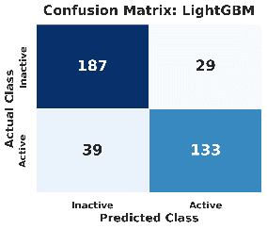
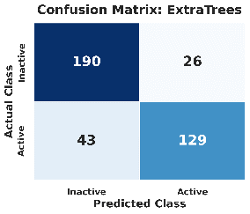 | 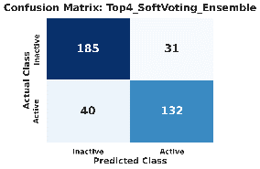
- Combined confusion matrices for XGBoost, LightGBM, ExtraTrees, and the Top-4 Soft-Voting Ensemble on the independent test set.

Feature Importance

Fig. 6 illustrates top 30 PaDEL descriptors by ensemble importance. Among all candidates, minHBint5 (minimum E-state hydrogen bond interaction at bond distance 5) was most influential, followed by IC2 and maxHBint7. While H-bond interaction descriptors and aromatic scaffold features were highly ranked, these findings remain correlative and require experimental validation.
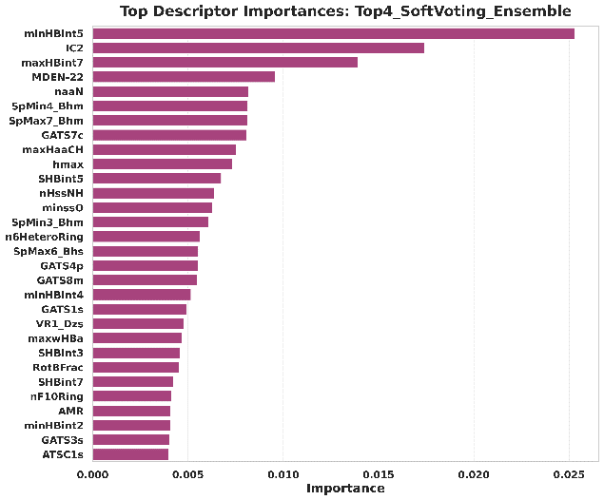
- Top 30 PaDEL descriptor importance’s from the Top-4 Soft-Voting Ensemble.

Y-Scrambling Validation
Table VI and Figs. 7–8 present the Y-scrambling results for 50 iterations. The scrambled ensemble attained a mean AUC = 0.506 ± 0.043 and a mean R² = −0.132 ± 0.055 across 50 iterations, suggesting no better than random classification. The results validate the model’s genuine understanding of the structure–activity relationship, evidenced by the AUC drop of 0.405 and the R² decrease of 0.648, compared to the original.

- Y-SCRAMBLING VALIDATION SUMMARY
Metric | Value
Original ensemble AUC | 0.911
Scrambled AUC mean ± SD | 0.506 ± 0.043
AUC drop | 0.405
Original ensemble R² | 0.517
Scrambled R² mean ± SD | −0.132 ± 0.055
R² drop | 0.648

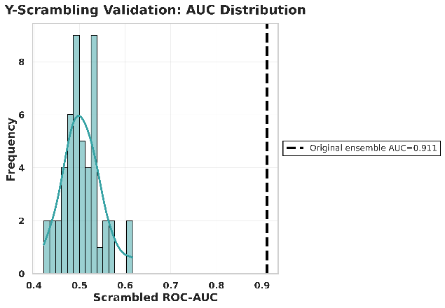
- Y-scrambling ROC-AUC null distribution. Scrambled AUC clusters near 0.5; the original AUC of 0.911 (dashed) is far removed, confirming model validity.

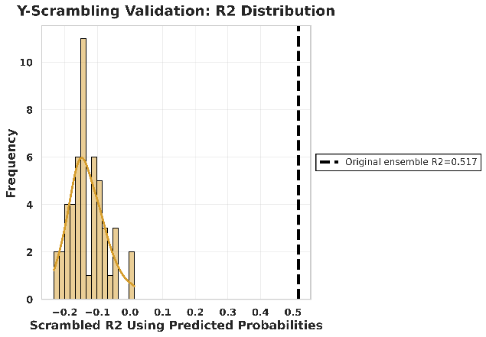
- Y-scrambling R² null distribution. Scrambled R² clusters near zero/negative; the original R² = 0.517 (dashed) confirms genuine predictive power.

- Top 100 Predicted HER2 Inhibitors
The final refitted ensemble was applied to the curated library as a demonstration ranking. Table VII lists the top 10 candidates by predicted active probability (all > 0.995). Top-ranked compounds carry acrylamide warheads consistent with covalent HER2 inhibition scaffolds, molecular weights of 488–541 Da, and LogP values of 1.4–2.7, indicating drug-like properties. Compounds with Lipinski violations ≥ 1 require downstream ADMET filtering.

- TOP 10 PREDICTED HER2 INHIBITOR CANDIDATES
Rank | ChEMBL ID | Prob. | pIC50 | IC50 (nM) | MW | LogP | HBD | Vio.
1 | CHEMBL5799738 | 0.9967 | 7.70 | 20.0 | 488.6 | 1.89 | 2 | 0
2 | CHEMBL6002962 | 0.9965 | 7.85 | 14.0 | 520.6 | 1.37 | 2 | 1
3 | CHEMBL5974482 | 0.9964 | 8.34 | 4.6 | 524.6 | 1.79 | 2 | 1
4 | CHEMBL6013449 | 0.9963 | 7.42 | 38.0 | 515.6 | 1.82 | 2 | 1
5 | CHEMBL5947037 | 0.9961 | 8.15 | 7.1 | 506.6 | 1.65 | 2 | 1
6 | CHEMBL5913102 | 0.9960 | 8.07 | 8.5 | 502.6 | 2.28 | 2 | 1
7 | CHEMBL5755605 | 0.9960 | 8.15 | 7.0 | 492.5 | 2.38 | 2 | 0
8 | CHEMBL5864772 | 0.9960 | 7.77 | 17.0 | 491.6 | 2.41 | 3 | 0
9 | CHEMBL5901533 | 0.9960 | 8.00 | 10.0 | 506.6 | 2.69 | 2 | 1
10 | CHEMBL5881010 | 0.9959 | 8.03 | 9.3 | 506.6 | 2.69 | 2 | 1

DISCuSsion
The multi-step curation pipeline ensured that compounds with only true IC50 measurements contributed to model training, avoiding noise from inequality-reported values prevalent in raw ChEMBL extracts [6]. RDKit-based standardization and salt stripping reduced structural inconsistencies, preventing artificially inflated model performance due to non-informative scaffold matching [11]. The dominance of gradient boosting and tree-ensemble methods over linear and kernel-based classifiers were resulted in the Benchmark of 30 classifiers, yielding the highest test AUC and MCC, consistent with kinase QSAR literature [13]. Underperforming linear models were still achieved AUC > 0.84, indicating meaningful linear signal in the descriptor space. The soft-voting ensemble (AUC = 0.911) marginally exceeded every individual model (best individual AUC = 0.908), which is consistent with variance reduction through probability averaging, with no loss in specificity [15].
The MCC value (0.628) reflects the combined performance of all four confusion matrix components, making it an important metric for bioactivity prediction [17]. Ensemble specificity of 85.6% is favorable for virtual screening, where minimizing false positives optimizes experimental resources [4]. Genuine learning of structure–activity relationships was verified through the Y-scrambling null distribution (mean AUC = 0.506), consistent with OECD QSAR validation guidelines [10]. Acrylamide scaffolds were the predominant feature among the top 100 predicted compounds, consistent with known irreversible HER2 covalent binders such as neratinib and osimertinib analogs. [3]. The final list of candidates requires molecular docking, molecular dynamics simulation, MM/GBSA free energy calculation, ADMET profiling, and wet-lab confirmation before any biological activity can be asserted.

Limitations
ChEMBL-based bioactivity values did not originate from any standardized experimental protocols, indicating potential measurement variability [6]. Ligand-based descriptor models do not account for receptor conformation or binding-pocket flexibility; structural validation via molecular docking is necessary [4]. The model's performance is constrained by the chemical space of the training set; as the entire screening pipeline was based on ChEMBL-derived bioactivity data, the top 100 predicted compounds are biased toward known chemical motifs and scaffold classes, limiting the efficiency of novel scaffold discovery. Experimental confirmation remained significant for the predicted inhibitors.

Conclusion
This study established an ensemble-based machine learning pipeline for HER2 inhibitor prioritization. A curated 1,939-compound IC50 dataset was constructed from ChEMBL, and 506 PaDEL molecular descriptors were finalized. Systematic benchmarking of 30 classifiers followed by soft-voting ensemble construction yielded a model with ROC-AUC = 0.911, MCC = 0.628, and specificity = 85.6% on an independent test set. The Y-scrambling test further validated the model's genuine learning of structure–activity relationships. The pipeline prioritized 100 candidate HER2 inhibitors with predicted active probabilities above 0.995, producing a ranked list for downstream molecular docking, ADMET analysis, and experimental validation. This methodology is extensible to other kinase targets with ChEMBL datasets with IC50 measurements.

References
[1] D. J. Slamon et al., "Human breast cancer: Correlation of relapse and survival with amplification of the HER-2/neu oncogene," Science, vol. 235, no. 4785, pp. 177–182, Jan. 1987.
[2] Y. Yarden and M. X. Sliwkowski, "Untangling the ErbB signalling network," Nature Reviews Molecular Cell Biology, vol. 2, no. 2, pp. 127–137, Feb. 2001.
[3] A. Arora and E. M. Scholar, "Role of tyrosine kinase inhibitors in cancer therapy," J. Pharmacol. Exp. Ther., vol. 315, no. 3, pp. 971–979, Dec. 2005.
[4] D. B. Kitchen, H. Decornez, J. R. Furr, and J. Bajorath, "Docking and scoring in virtual screening for drug discovery," Nature Reviews Drug Discovery, vol. 3, no. 11, pp. 935–949, Nov. 2004.
[5] A. Cherkasov et al., "QSAR modeling: Where have you been? Where are you going to?" J. Med. Chem., vol. 57, no. 12, pp. 4977–5010, Jun. 2014.
[6] A. Gaulton et al., "ChEMBL: A large-scale bioactivity database for drug discovery," Nucleic Acids Research, vol. 40, no. D1, pp. D1100–D1107, Jan. 2012.
[7] T. Chen and C. Guestrin, "XGBoost: A scalable tree boosting system," in Proc. 22nd ACM SIGKDD, San Francisco, CA, 2016, pp. 785–794.
[8] G. Ke et al., "LightGBM: A highly efficient gradient boosting decision tree," in Advances in NeurIPS, vol. 30, 2017, pp. 3146–3154.
[9] C. W. Yap, "PaDEL-Descriptor: An open source software to calculate molecular descriptors and fingerprints," J. Comput. Chem., vol. 32, no. 7, pp. 1466–1474, May 2011.
[10] A. Tropsha, "Best practices for QSAR model development, validation, and exploitation," Mol. Informatics, vol. 29, no. 6–7, pp. 476–488, Jul. 2010.
[11] G. Landrum, "RDKit: Open-source cheminformatics," 2023. [Online]. Available: https://www.rdkit.org
[12] S. Kanwal et al., "Machine learning approaches for prediction of HER2 inhibitory activity," Frontiers in Pharmacology, vol. 9, p. 1045, Sep. 2018.
[13] Y.-C. Lo, S. E. Rensi, W. Torng, and R. B. Altman, "Machine learning in chemoinformatics and drug discovery," Drug Discovery Today, vol. 23, no. 8, pp. 1538–1546, Aug. 2018.
[14] V. Svetnik et al., "Random forest: A classification and regression tool for compound classification and QSAR modeling," J. Chem. Inf. Comput. Sci., vol. 43, no. 6, pp. 1947–1958, Nov. 2003.
[15] R. P. Sheridan, "Deep neural nets as a method for quantitative structure–activity relationships," J. Chem. Inf. Model., vol. 55, no. 11, pp. 2324–2337, 2015.
[16] Z. Wu et al., "MoleculeNet: A benchmark for molecular machine learning," Chemical Science, vol. 9, no. 2, pp. 513–530, 2018.
[17] S. Boughorbel, F. Jarray, and M. El-Anbari, "Optimal classifier for imbalanced data using Matthews Correlation Coefficient metric," PLOS ONE, vol. 12, no. 6, p. e0177678, Jun. 2017.

